# How to download data from BIOFTP server?

Before you begin:

* We should already email you USER and password (both case-sensitive)
* **Mac**: download Cyberduck https://cyberduck.io/?l=en 
* **Windows**: download FileZilla [https://filezilla-project.org/](https://filezilla-project.org/)

Download:

* **Linux** :

1. Log in to BIOFTP: sftp [USER@bioftp.researchcomputing.asu.edu](mailto:USER@bioftp.researchcomputing.asu.edu)
2. Type in password
3. Retrieve data: get –r *

* **Mac**

1. Log in to BIOFTP by Cyberduck: click Open Connection



1. Connect by SFTP: type in server, username and password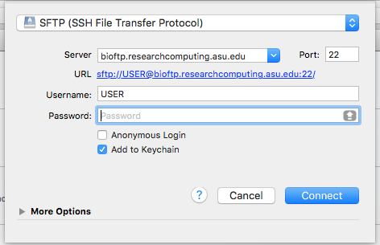
2. Once log in, download by right-click files

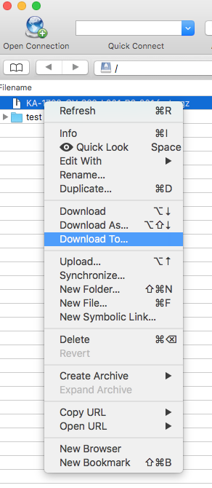

* **Windows**

1. Fill in host, username, password, and port as displayed below then hit Quickconnect.

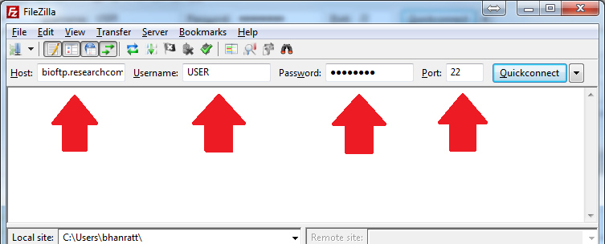

1. **You can either right click and hit Download or drag and drop the file.**

